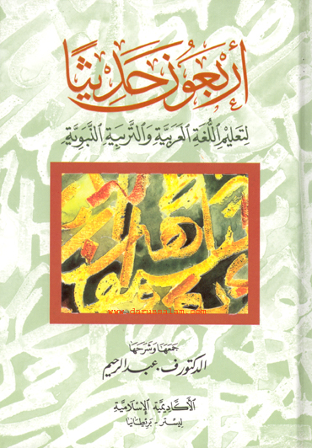
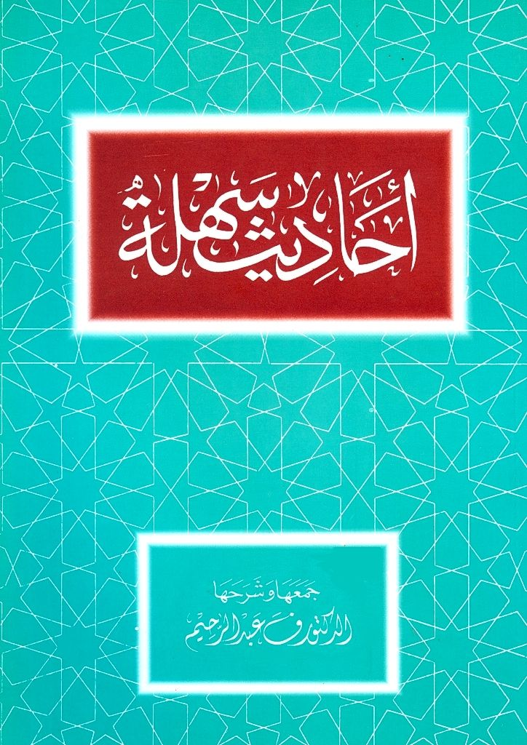
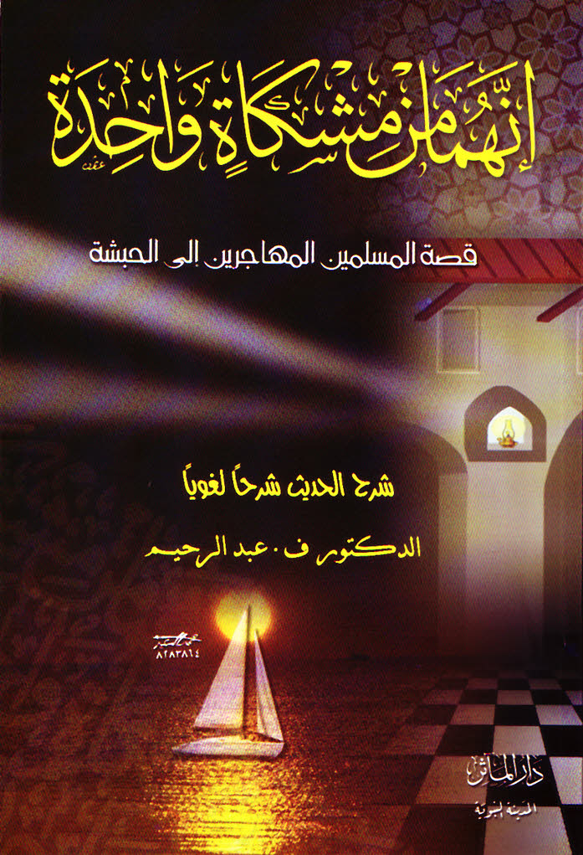
DrVaniya.com

Study the first book in the volume in new, audio-visual format on-line,
Or Download,
Or Purchase.

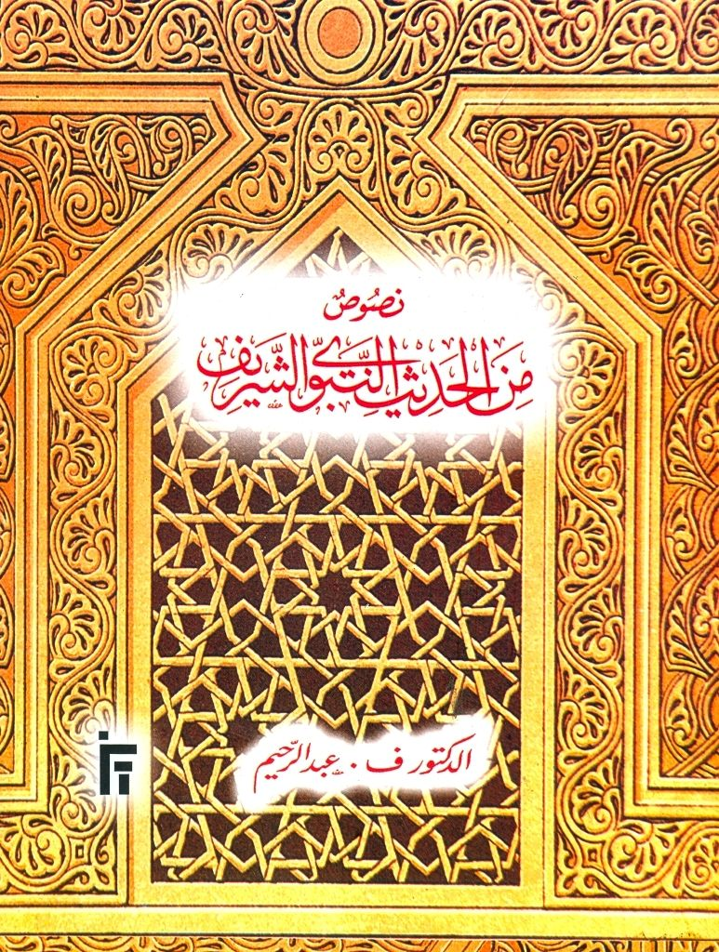
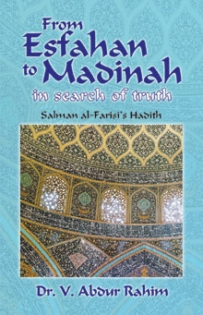

The first book published in أَرْبَعُونَ حَدِيثاً is أَحَادِيثُ سَهْلَةٌ .
For a free on-line, audio-visual study of أحَادِيثُ سَهْلَةٌ ,
please see Beginner’s Library under ‘aHaadiith sahlah’.

Free download of أحَادِيثُ سَهْلَةٌ :
Please see Beginner’s Library under ‘aHaadiith sahlah’

Buy the complete volume on-line:
* Beautiful print
* Hard-back cover,
* Harakaatu l-I”raab placed on all the words.

Shipping from U.S.A: View extracts from Contents & Index here:
http://www.onlineislamicstore.com/b9839.html
Shipping from U.K:
http://www.darussalam.com/index.php/arbaouna-hadith-arabic.html

