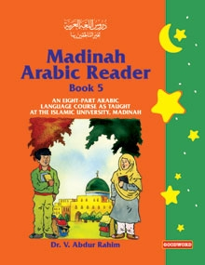
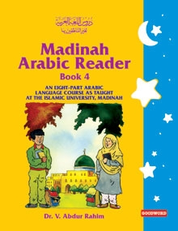
DrVaniya.com
Book Fair &
Library

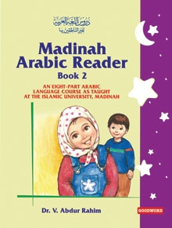
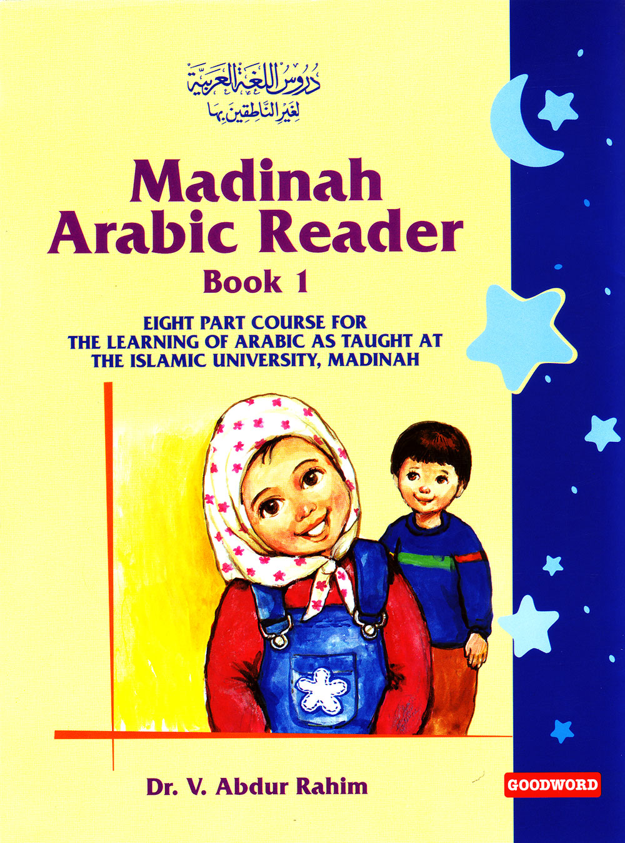
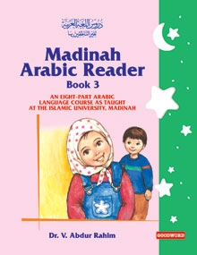

Language of the Qur'aan

Covers copyright: Goodword Books.

Purchase Information
DrVaniya.com

Place your orders on-line from various bookstores worldwide, e.g.:

- Shipping from the Publishers: Goodword Books (India):

http://www.goodwordbooks.com/authors_books_details.php?authorID=28

- Shipping from UK:

http://www.darussalam.com/Learn-Arabic/c70/p928/Madinah-Arabic-Reader-Book-1/product_info.html

- Full-Set (Vols. 1-5) in one package (U.K. shipping):

http://www.darussalam.com/Learn-Arabic/c70/p2024/Madinah-Arabic-Reader-Full-set-vol-1-to-5/product_info.html

May Allaah increase you in knowledge.

