Purchase Information
DrVaniya.com

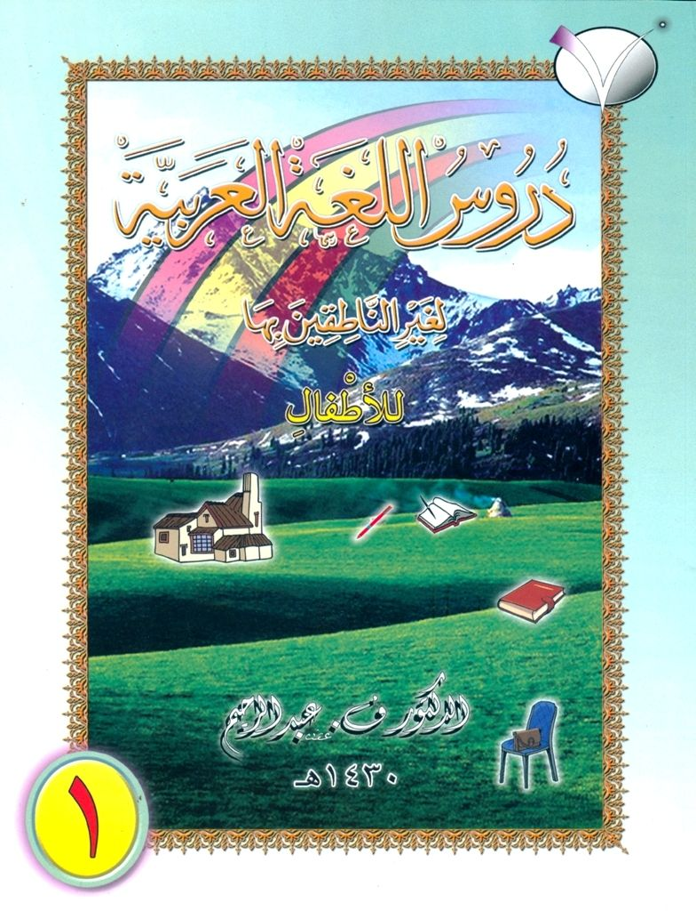
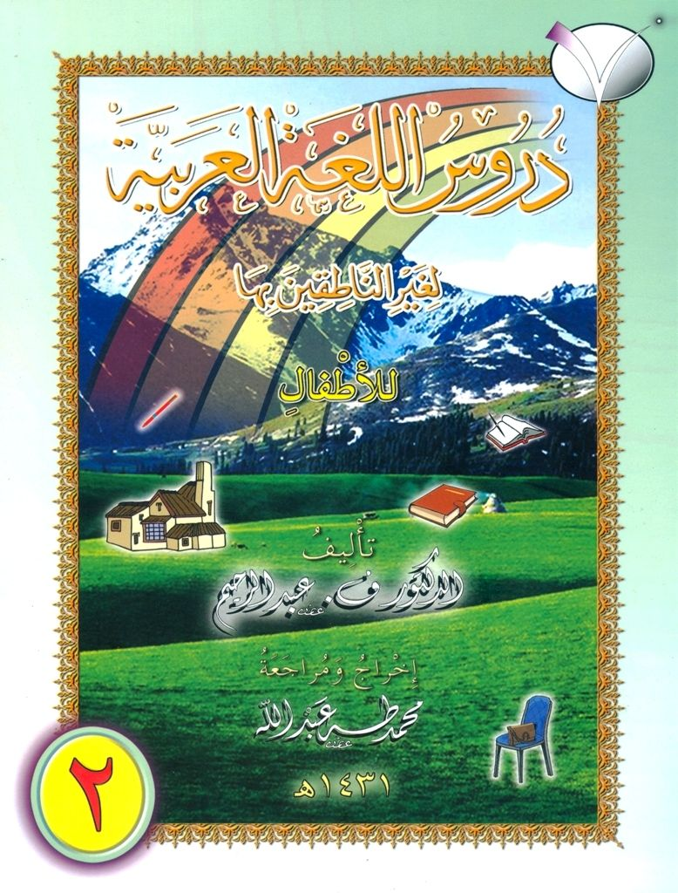
دُرُوسُ اللُّغَةِ الْعَرَبِيَّةِ
لغير الناطقين بِها
للأَطْْفَالِ

‘Arabic Reader for Children – Volumes 1 & 2’

by Shaykh Dr . V. Abdur Rahim

Place your orders on-line:

Volume 1:

http://www.ift-chennai.org/products-page/arabic-publications/arabic-reader-for-children-vol-i/

Volume 2:

http://www.ift-chennai.org/products-page/arabic-publications/arabic-reader-for-children-vol-ii/

(Arabic-only)

May Allaah increase you in knowledge.

